Making Known the Love of Christ!
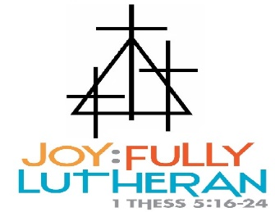
“Soaring High in Gods Words”
CLASSROOM NAME: _Raccoons January Calendar______
TEACHERS: _Mrs. Rahn & Mrs. Duffy____________
(other info) | MONDAY | TUESDAY | WEDNESDAY | THURSDAY | FRIDAY
Theme: |  |  | 1  New Year’s Day! | 2  Child Care Resumes | 3  Friday Dance Party
Theme:  Outer Space | 6  Bible Story:  Jesus as a Young Boy | 7  Literacy:  Read My O Book  Art:  Letter O | 8  Fine Motor:  Space Playdough Tray | 9  Art:  God Made Outer Space and God Made ME | 10  Dramatic Play:  Trinity’s Space Shuttle
Theme:  Outer Space | 13  Bible Story:  Jairus Daughter Lives | 14  Literacy:  Read My P Book  Art:  Letter P | 15  Art:  Star Fun | 16  Math:  Space Stew | 17  Blocks:  STEM Building Robots
Theme:  Outer Space | 20  NO SCHOOL  CHILD IS OPEN FOR THOSE THAT SIGNED UP | 21  Bible Story:  Jesus Heals the Blind Man | 22  Literacy:  Read My Q Book  Art:  Letter Q | 23  Literacy:  Read It Build It Write It Space | 24  Friday Dance Party!
Theme:  Outer Space | 27  Bible Story:  Jesus Feeds 5000 | 28  Literacy:  Read My R Book  Art:  Letter R | 29  Sensory Table:  Moon Exploration | 30  Art:  I love you more than all the stars in the sky | 31  Movie Friday!  Magic School Bus to Outer Space
NOTES:

