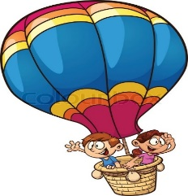
Making Known the Love of Christ!
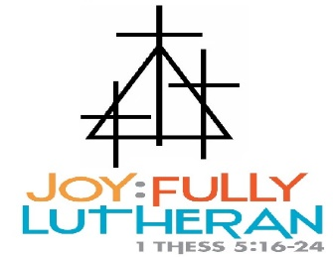
“Soaring High in Gods Words”
CLASSROOM NAME: _Raccoons’ November Calendar______
TEACHERS: _Mrs. Rahn & Mrs. Duffy____________
(other info) | MONDAY | TUESDAY | WEDNESDAY | THURSDAY | FRIDAY
Theme:  Pizza  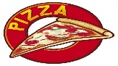 | 4  Bible Story:  Crossing the Red Sea | 5  Literacy:  Read My I Book  Letter: I Art | 6  Dramatic Play:  Trinity’s Pizzeria | 7  Math:  Graph: What is your favorite pizza topping? | 8  No School  Child Care Open for those that signed up!
Theme:  Pizza | 11  Bible Story:  Israel in the Desert | 12  Math:  Spot and Dot the number 10  Literacy:  Read My J Book | 13  Small Motor  Pizza Playdough Tray  Art:  Letter: J | 14  Art:  Making Pizza’s | 15  No Child Care-  Staff is attending a professional development conference
Theme:  Pizza  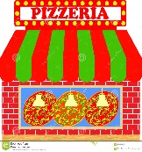 | 18  Bible Story:  The Ten Commandments | 19  Math:  Spot and Dot the number 11  Literacy:  Spot and Dot the letter K | 20  Block Center:  Stem Challenge:  Building a campsite | 21  Math:  Turkey Stew | 22  Discovery:  Parts of a bat
Theme:  Pizza | 25  Bible Story:  The Bronze Snake | 26  Literacy:  Read My L Book  Letter: L Art | 27  Child Care Closes at Noon | 28  Happy Thanksgiving!  Child Care Closed  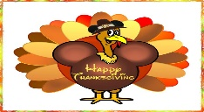 | 29  Thanksgiving Break!  Child Care Closed!  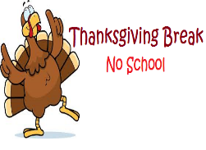
NOTES:

